Thejasvenan T. 220638J
ME 2261 - Embedded Systems Log Book
Day 07 – 12.09.2025
Task 01
Write AVR assembly program to create approx. 1 millisecond delay using conditional jump instructions without using built-in delay functions or timers.
Assuming:
CPU Clock: 8MHz
Each instruction takes 1 cycle (unless branching)
We’ll use nested loops and conditional branches.
Frequency = 1/Time taken for 1 clock cycle
Time taken for 1 clock cycle $= \frac{1}{8×{10}^{6}}s=0.125 μs$
Maximum no. of loops that can be perform using 8-bit register $=$ 255
Time taken for 1 loop $=\frac{1000 μs}{255}=3.92 μs$
No. of cycles required for 1 loop $=\frac{3.92 μs}{0.125 μs}\sim 31 cycles$
No. of instructions required for 1 loop $=31$
Total No. of clock cycles $=31×255= 7905$
Total Time taken = $7905×0.125 μs=988.125 μs \sim 1 s$
No. of Constant instructions required $=\frac{1000-988.125 }{0.125}=95$ (I’ve used only 2)
But the Branching instruction clock cycle can be 2 mostly.
so the time delay of 1 ms can be achieved approximately.
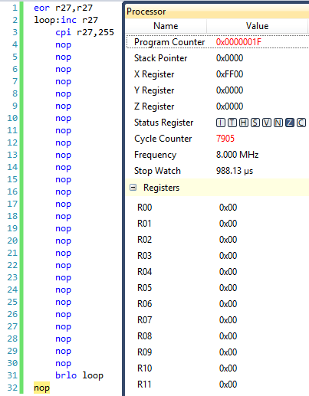

Task 1
To make output signal of 1 and 0 for each of 5 clock cycles.
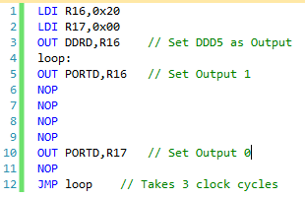
Task 2
To make output signal of 1 and 0 for each of 1 ms time interval.
For CPU Clock: 8MHz
Each instruction takes 1 cycle (unless branching)
Calculation for the number of instructions are made similar to the first task, where loop
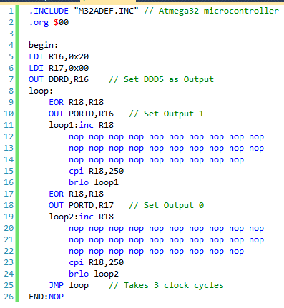

The .hex file of the AVR Program is flashed into the Atmega32A microcontroller using eXtreme Burner – AVR. Then PD5 Pin and GND pin is connected with channel 1 of Digital Oscilloscope, and got the graph like below: Indicating the amplitude voltage and period of a pulse of 5V and 1000 µs.
